**Superior University Reiwend Road**

Name: Haseeb Arshad

Roll no: SU92–BSSEM-F22-177

Section:5D

Subject: CN Lab  
Task 5

Submitted to: Sir Rasikh Ali

**Task 1;**

**Design network of "Lab-7" and “Lab-8” (2-3 rows of computers) & “Admin” Use: • Server (for each, total 3) • Switch (3) • Router (1) • End-Devices like Laptop/PC Assign them IP Address**

**(Dynamically/DHCP) • Lab 7: 192.168.1.0 • Lab 8: 172.168.5.0 • Admin: 158.168.4.0**

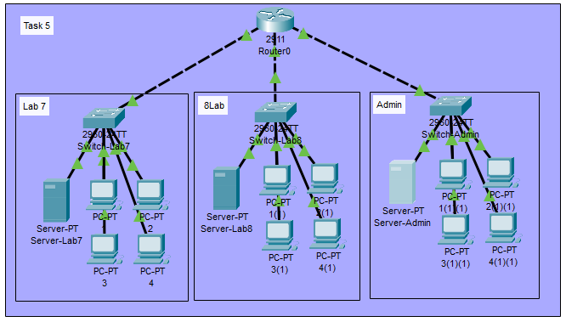

**Configure Router:**

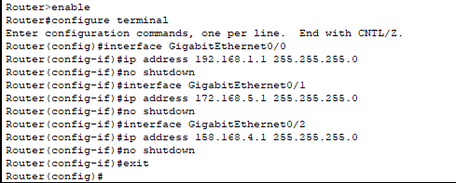

**Configure DHCP on Servers:**

**Lab7:**

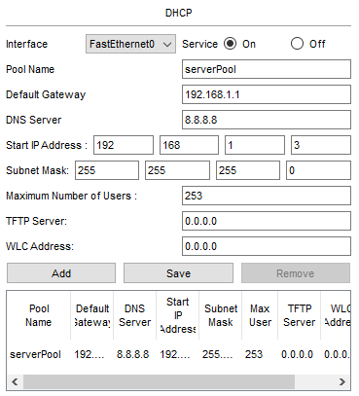

**Lab8:**

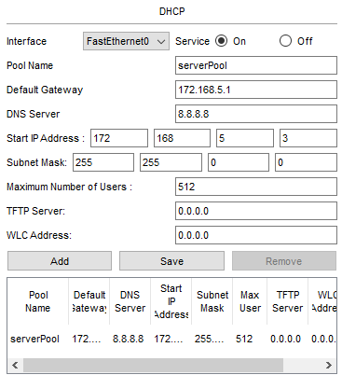

**Admin:**

